1. **Finding mail servers of ibm.com and wipro.com**

**Cmd=nslookup**

**set type=mx**

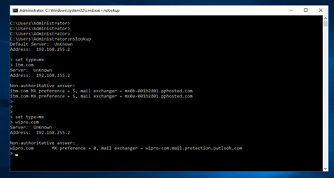

1. Finding location of a particular mail using email headers.

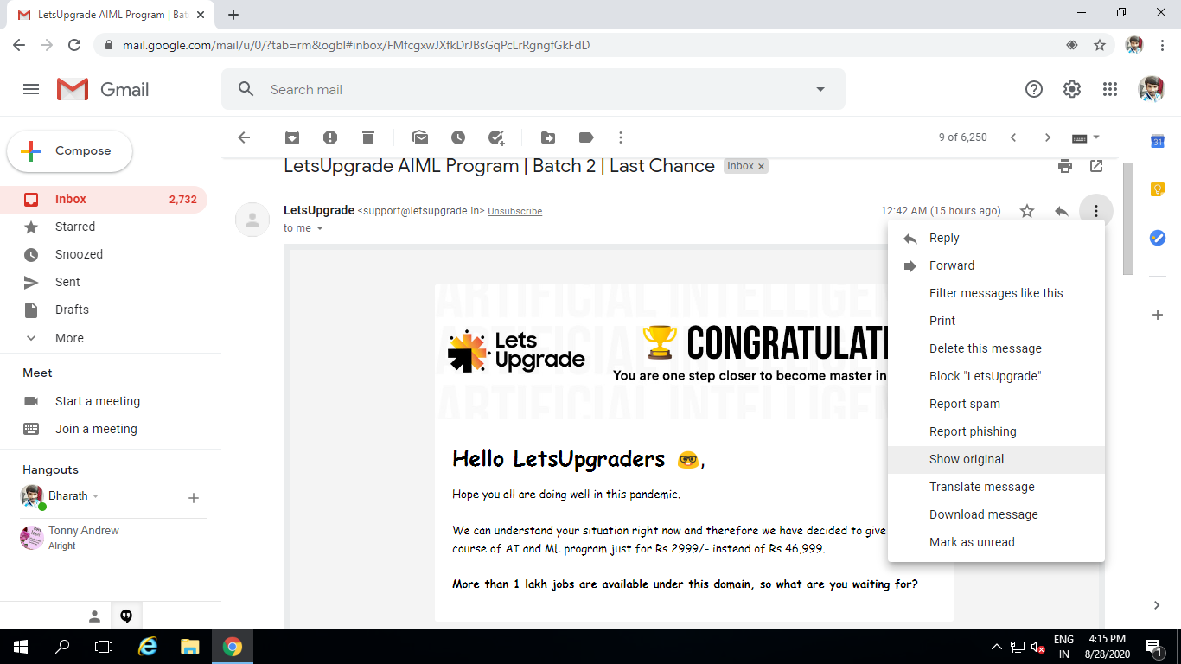

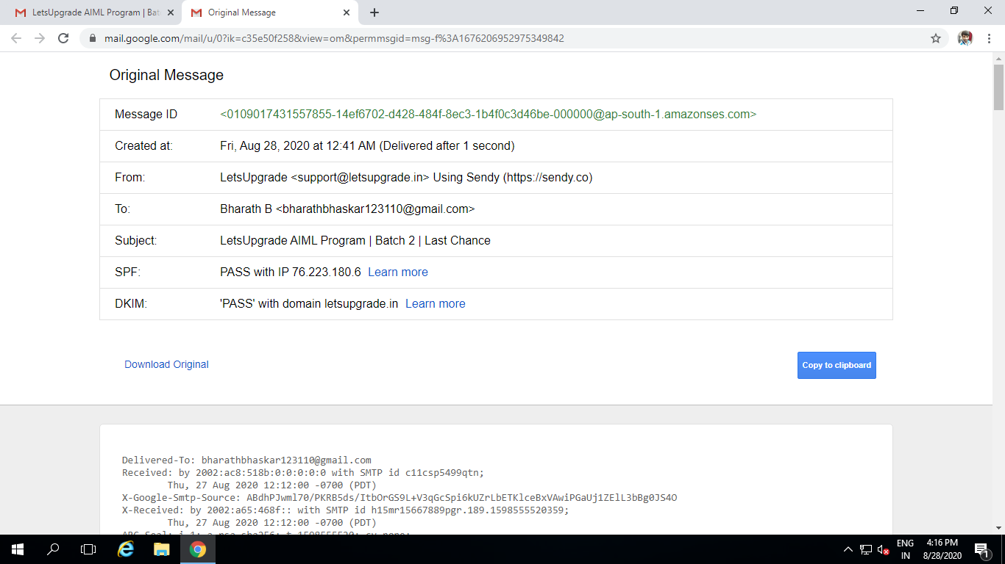

Now using Email tracker pro we can trace the email address location

1. Scanning and finding port number open in ip address 203.163.246.23

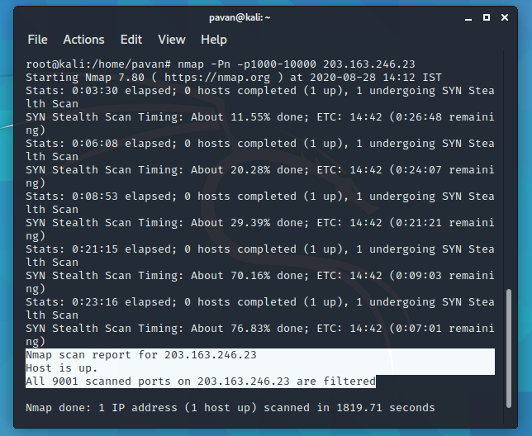

1. Install nessus in a vm and scan your laptop for CVE

Since I dint have business email address I could not download the software and try it.